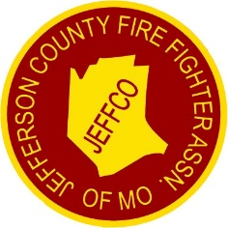 | CITY OF HERCULANEUM  #1 Parkwood Court, Herculaneum, Missouri 63048-1318  City Hall: 636.475.4447 • Fax: 636.475.6191 • www.cityofherculaneum.gov | 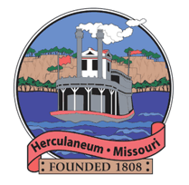

2026 Jeffco Fire Engine Rally & Fall Festival
Vendor / Exhibitor Application
Saturday, September 26, 2026
Which event(s) would you like to set up for? (Check one or both — you're welcome to join us for one event or the whole day!)
☐ Fire Engine Rally  Morning event | ☐ Fall Festival  Evening event

BUSINESS INFORMATION
Business / Vendor Name

Contact Person

Mailing Address (Street, City, State, Zip)

  Business Phone
  Cell Phone
Email Address

ALTERNATE CONTACT (OPTIONAL)
Name

  Business Phone
  Cell Phone
BOOTH & SETUP DETAILS
You'll be operating out of a:
☐ Food Truck ☐ Trailer ☐ Booth(s)
Number of 10' x 10' Booths Needed (first come, first served)

Type of Merchandise / Items Sold or Displayed

Special Requirements

VENDOR FEES
$50.00 | Sales & Food Vendors
$20.00 | Informational (Non-Sales)
Please make checks payable to: City of Herculaneum
SIGNATURE
  Signature
  Date

Return completed application to: kplouder@cityofherculaneum.gov and mail to with payment: City of Herculaneum, 1 Parkwood Court, Herculaneum, MO 63048

