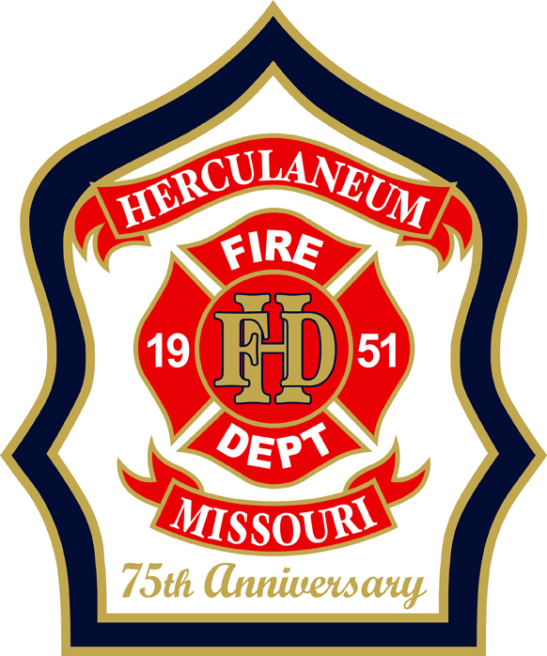 | HERCULANEUM FIRE DEPARTMENT  75th Anniversary Water Parade  Official Parade Entry Form
Saturday, August 8, 2026 • Taylor Early Childhood Center to William C. Haggard Park • Joachim Avenue, Herculaneum, MO
UNIT / ENTRY INFORMATION
Unit / Group Name
Entry Category | ☐ Fire / Emergency Apparatus ☐ School or Youth Group ☐ Business / Sponsor ☐ Community Organization ☐ Walking Group ☐ Other
Brief Description of Entry (vehicle, float, theme, etc.)
Will Unit Use Water? | ☐ Squirt Guns ☐ Hose / Tank ☐ None
UNIT CAPTAIN (18 or older — responsible for this entry)
Full Name
Phone
Email
ACKNOWLEDGMENT & WAIVER
By signing below, the Unit Captain confirms they have read and agree to follow the Parade Entry Rules provided by the Herculaneum Fire Department, including:
☐ Only clean tap water may be used; no additives, dyes, or ice water
☐ No spraying water directly at anyone's face at close range
☐ No riding on hoods, tailgates, or running boards unless a secured seat is provided
☐ No alcohol, and no throwing items from a moving vehicle
The undersigned releases and holds harmless the Herculaneum Fire Department, the City of Herculaneum, and event volunteers from any claims of injury, loss, or damage arising from participation in this event, except to the extent caused by their gross negligence.
Signature | Date
SUBMIT COMPLETED FORMS TO: Email: mwadlow@cityofherculaneum.gov Phone: 636-475-3080

