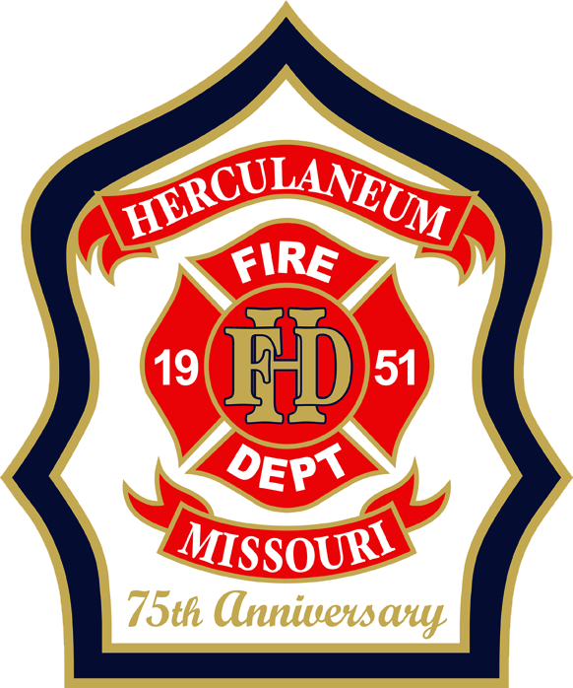 | 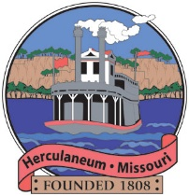  HERCULANEUM FIRE DEPARTMENT  75th Anniversary Water Parade  Food Vendor Sign-Up Form
Saturday, August 8, 2026 • Parade begins 2:00 PM • William C. Haggard Park, 776 Joachim Ave, Herculaneum, MO
VENDOR & CONTACT INFORMATION
Business Name
Contact Name
Email
Phone
Mailing Address
FOOD / PRODUCT INFORMATION
Type of Food / Items Offered
Brief Menu Description
SPACE & SETUP NEEDS
Space Needed | ☐ 10' x 10' ☐ 10' x 20' ☐ Other (specify below)
Other Space Requirement
Electricity Needed? | ☐ Yes ☐ No
Bringing Own Generator? | ☐ Yes ☐ No
SPECIAL REQUESTS / NOTES
Notes

By signing below, the vendor agrees to arrive and be fully set up before the 1:00 PM public arrival window, and to follow all event rules and directions from the City of Herculaneum and the Herculaneum Fire Department staff on the day of the event.
Vendor Signature | Date
SUBMIT COMPLETED FORMS TO:
Herculaneum Fire Department — Matt Wadlow – Email: mwadlow@cityofherculaneum.gov - Phone:636-475-3080

