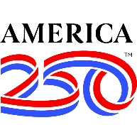
CITY OF HERCULANEUM
#1 Parkwood Court • Herculaneum, Missouri 63048
City Hall: 636.475.3080 • Fax: 636.475.6191 • www.CityofHerculaneum.gov
Independence Day Celebration • Exhibitor / Vendor Application
Friday, July 3, 2026 776 Joachim Avenue Herculaneum MO, 63048
1. Business & Contact Information

Company / Business Name:

Contact Person:

Street Address:

City: |  | State: | ZIP Code:
Business Phone: | Cell Phone:
Email Address:

2. Booth & Setup Details

Operating Out Of (select all that apply):
☐ Food Truck | ☐ Trailer | ☐ Booth(s)
Type of Merchandise Sold or Displayed:

3. Submission & Signature

Return Completed Application To: kplouder@cityofherculaneum.gov
Or mail to City of Herculaneum • #1 Parkwood Court • Herculaneum, MO 63048

Authorized Signature: | Date:

Questions? Contact City Hall at 636.475.3080 • www.CityofHerculaneum.gov

